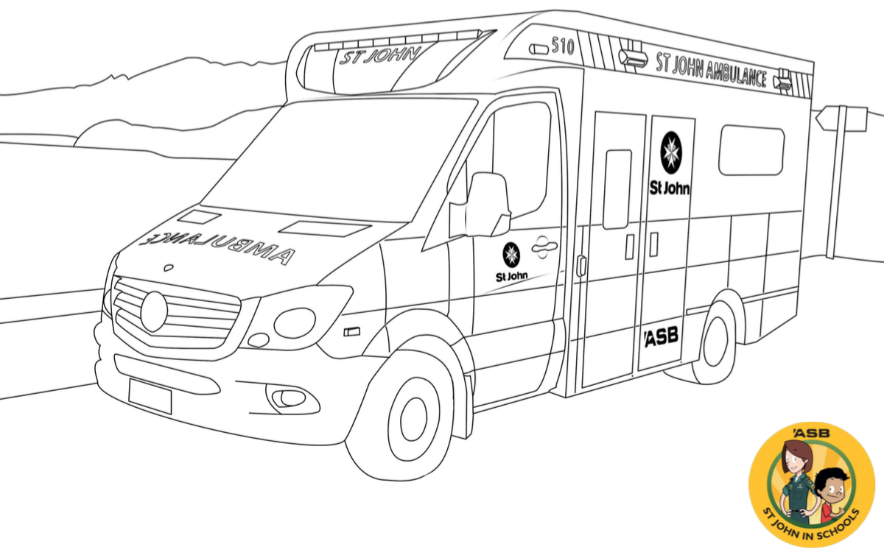
Once you’ve coloured in then take a photo and tag @angelstarpublishinghouse on Facebook or Instagram – every month we give away a FREE copy of ‘Call For The Ambulance, Feat. 111 Ambulance Song’ to one lucky entrant!

CALL FOR THE AMBULANCE is available in all leading book stores nationwide or at www.angelstar.co.nz

